**DBDA Sept 2022 Data Visualization Exam**

|  |  |
| --- | --- |
| Name | Akshay Madhukar Patil |
| Roll No. | 220943025024 |
| Paper Set No. | I |
| Date | 2/2/2023 |
| Tableau Public URL | Q1. <https://public.tableau.com/app/profile/akshay.patil1576>  Q2. <https://public.tableau.com/app/profile/akshay.patil1576> |

1. Put your Question 1 answer screen shots below

1)

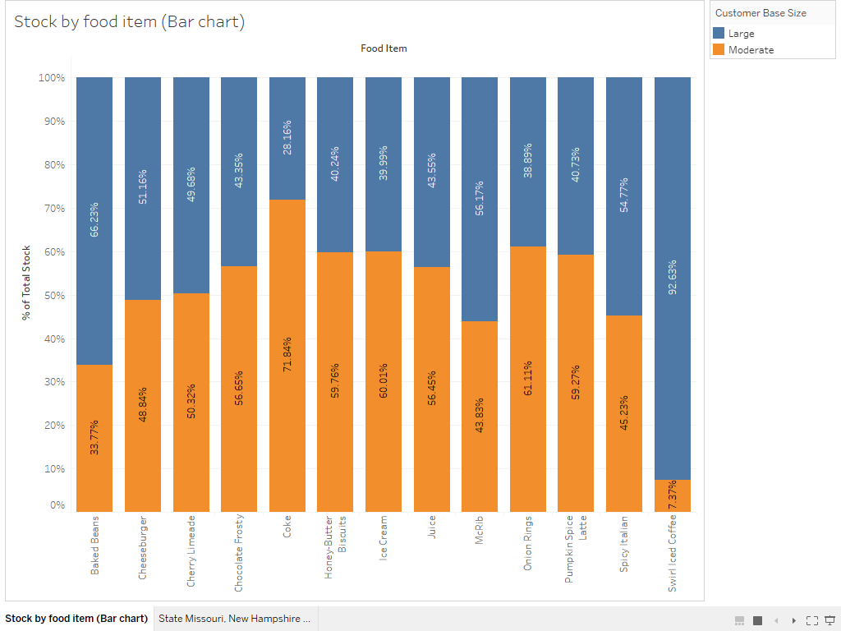

2)

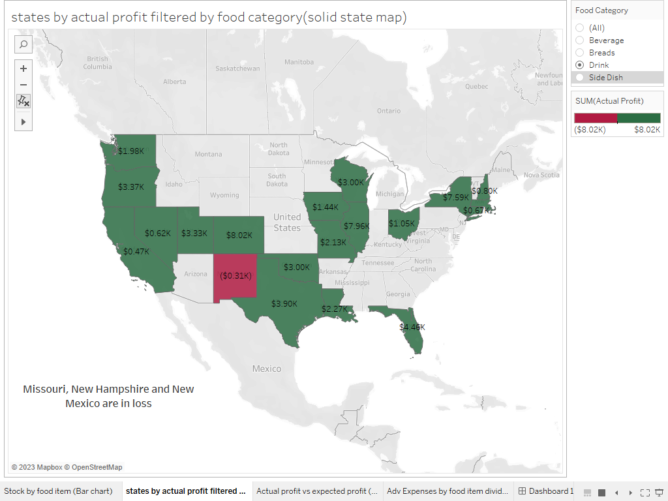

3)

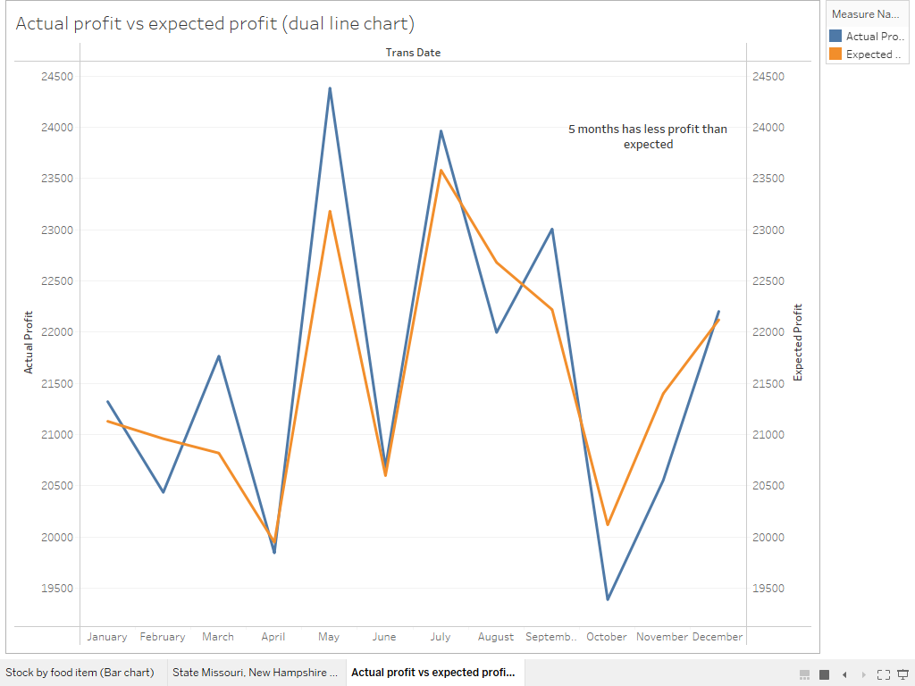

4)

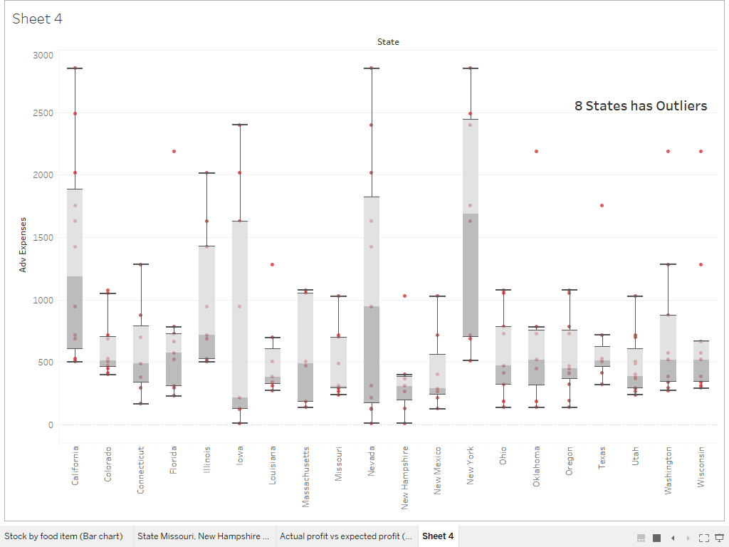

5)

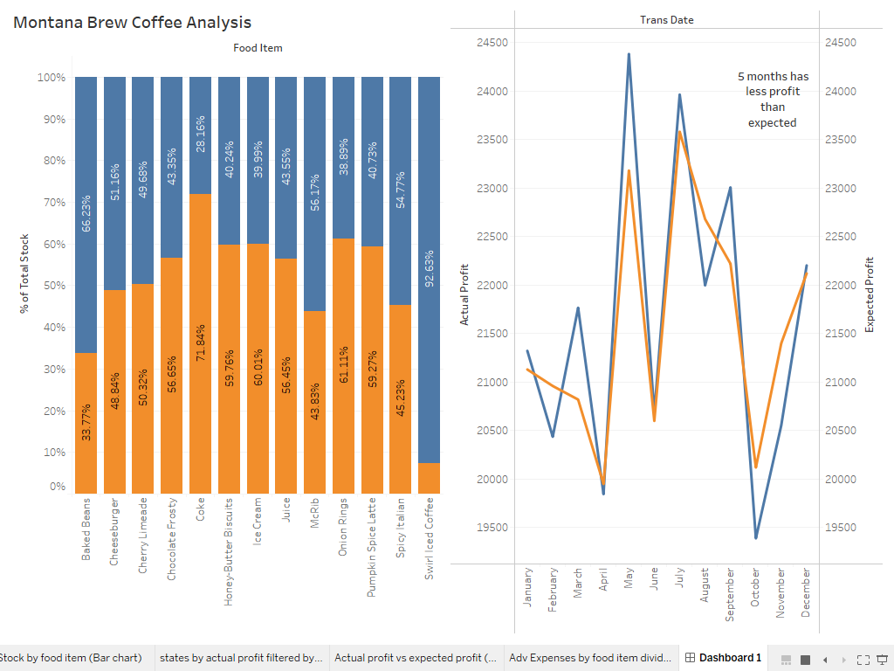

1. Put your Question 2 answer screen shots below

1)

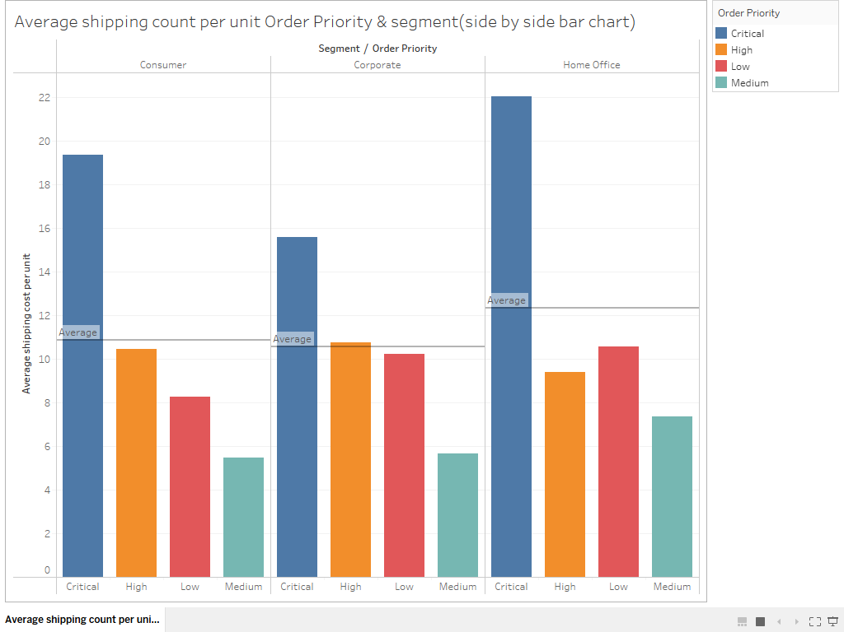

2)

3)

4)

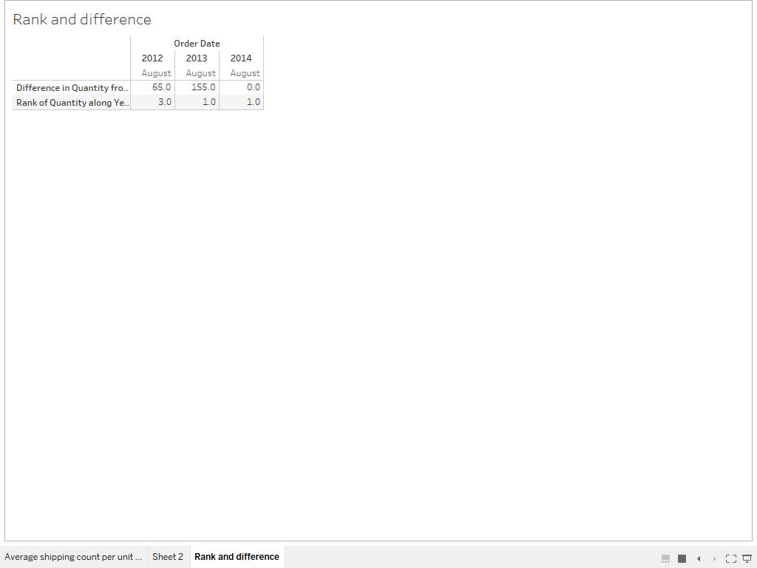

5)